H2
ANDERSON JUNIOR COLLEGE
HIGHER 2

CANDIDATE
ANSWERS
NAME

PDG
INDEX NUMBER
PDG
I

BIOLOGY 9648/03

Applications Paper and Planning Question 18 September 2012
Paper 3

2 hours
Additional Materials: Answer Paper

READ THESE INSTRUCTIONS FIRST

Write your name and PD group on all the work you hand in.
Write in dark blue or black pen.
You may use a soft pencil for any diagrams, graph or rough working.
Do not use paper clips, highlighters, glue or correction fluid.

Answer all questions.

All working for numerical answers must be shown.
For Examiner’s Use
1
2
3
4
5
Total | 72
At the end of the examination, fasten all your work securely together.
The number of marks is given in brackets [ ] at the end of each question or part question.

Calculators may be used

This document consists of 15 printed pages and 1 blank page.
Answer all the questions.

1 |  | Human growth hormone (hGH) is essential for normal growth and development. Currently, recombinant hGH synthesised via genetic engineering is exclusively used to treat GH deficiency. Prior to the development of genetic engineering, hGH is obtained mainly from cadavers (dead body).
 | (a) | Explain the advantages of obtaining hGH gene from a cDNA library instead of a genomic DNA library.  - hGH gene isolated from cDNA library contains only coding regions/ does not contain introns but gene isolated from genomic DNA library contains both coding and non-coding sequence;  - Bacterial cells used for cloning cannot undergo RNA processing/remove introns/RNA splicing;  - hGH gene isolated from cDNA library is intact but gene isolated from genomic DNA library may be fragmented;  - Easier to find the hGH gene from cDNA library since it smaller;  [max 3m] | [3]
 | (b) | The plasmids used for cloning hGH gene were obtained from E. Coli and modified to contain the following:  - Resistance genes for antibiotics kanamycin and ampicillin.  - Prokaryotic promoter sequence (P) upstream of the ampicillin gene  - Polylinker site which contains recognition sites of 7 different restriction enzymes, all producing sticky ends.  Fig. 1.1 shows the plasmid used for cloning:  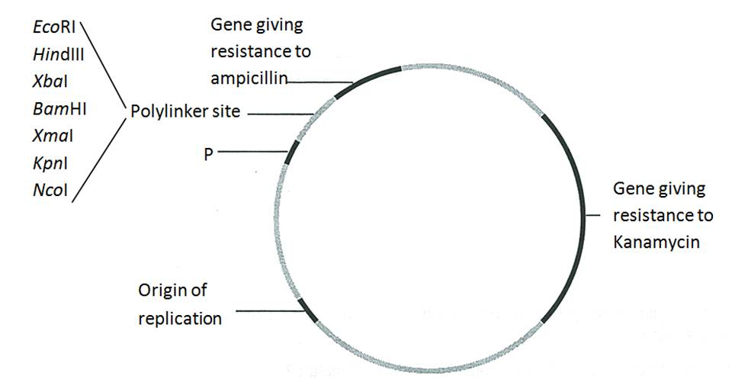  Fig. 1.1  The cDNA of hGH gene, with the restriction sites flanking the gene, is shown in Fig 1.2.  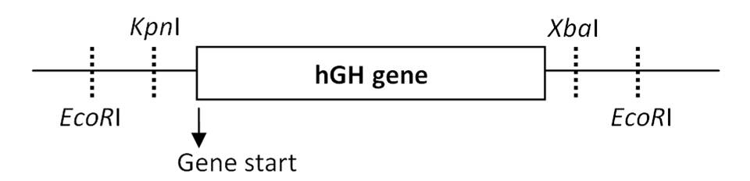  Fig. 1.2
 | (i) | In order to obtain a recombinant plasmid containing the hGH gene, the hGH cDNA and cloning plasmids are first digested with restriction enzymes prior to annealing them together.  State the restriction enzymes used in order to obtain optimum gene expression.  KpnI & XbaI; / KpnI & EcoRI; | [1]

 | (ii) | Explain your choice of restriction enzymes.  - Create two different sticky ends, KpnI near to the gene start site and Xba I/EcoRI at the gene end;  - Ensure only 1 correct orientation of inserting the gene (Transcription can occur in the correct direction);  - Prevent self annealing of gene/plasmid;  [max 2m] | [2]
The recombinant plasmids were transformed into E.Coli cells. Selection of recombinant bacterial clones was then carried out by culturing them on media containing antibiotics. The same colonies are plated in the same grid positions on the two plates shown below.

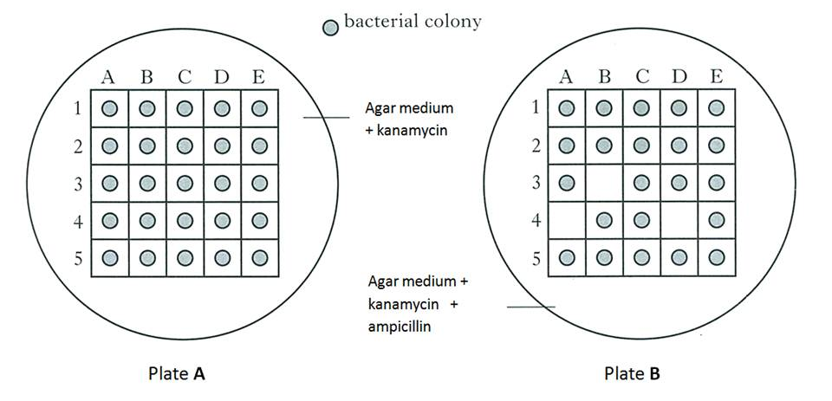
Fig. 1.3

 | (c) | State and explain which colonies contained the recombinant plasmids with hGH gene.  - A4, B3 and D4;  - Antibiotic gene ampicillin has been insertionally inactivated/disrupted by hGh gene→ bacterial cannot expressed (ampicillin) resistance protein (and killed by ampicillin); | [2]

 | (d) | A pharmaceutical company tried to produce hGH using the same method described but they transformed another species of bacterial cells with the recombinant plasmids. Recombinant plasmids were successfully inserted into the bacterial cells but after several generations, the bacterial cells were unable to grow on the kanamycin medium.  Suggest a possible reason.  - Recombinant plasmid from E.coli unable to replicate in this type of bacterial cells;  - DNA polymerase from these bacteria unable to recognize the origin of replication on the E.coli plasmids used for cloning; | [2]
 | (e) | Explain the advantages of being able to transfer hGH genes into bacteria.  - Protein produced is identical to those produced in the human body - > will not stimulate immune responses;  - Can be produced in large quantity;  - Overcomes ethical objections due to obtainment of growth hormones from cadavers;  [max 2m] | [2]
 |  | [Total: 12]

2 |  | Cystic fibrosis (CF) is a genetic disorder caused by mutations in the gene that code for the CF transmembrane conductance regulator (CFTR) that contributes to regulation of ion flux at the membrane of epithelial cells.  A polymorphic DNA segment, KM-19 found within 1 Centimorgan of the CFTR gene has been identified. This segment exhibits restriction fragment length polymorphism (RFLP) that can be used as a marker for the genetic screening of CF.  Fig. 2.1 shows the positions of various restriction sites of a segment of KM-19 and a probe that can be used to detect the polymorphism. Allele 2 is linked to the mutant CFTR allele.  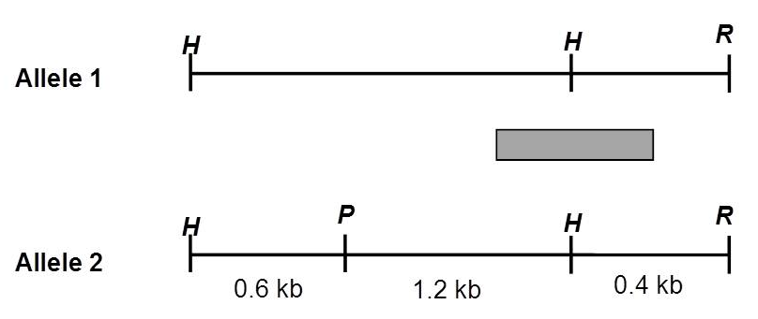  Diagram not drawn to scale  H, P and R represent restriction sites HindIII, PstI and EcoRI respectively.  Fig. 2.1
 | (a) | With reference to information in the question and Fig. 2.1, explain why KM-19 can be used as a genetic marker for the detection of the mutant CFTR allele.  Linkage  - tightly linked to CFTR gene / located very close on the same chromosome as CFTR;  - 1% chance that crossing-over will occur between allele 2 and the mutant CFTR allele during gamete formation / 1 % chance that allele 2 and the mutant CFTR allele would always be inherited together as one unit ( accept mention of recombination frequency as 1%);  Polymorphic  - At the same genetic locus, allele 1 has no restriction site for Pst1 while allele 2 has one restriction sites for Pst 1;  - Leads to varying length of restriction fragments upon cutting with Pst 1: allele 1 – 2.2kb , allele 2 – 1.6kb;  - Presence of 1.6kb fragment (accept allele 2 if length of fragments mentioned in earlier answer ) mean that the mutant CFTR allele is present; ( reject: presence of 1.6kb fragment implies that the person has CF)  [max 4m] | [4]
 | (b) | The first step of genetic screening for CF involves performing polymerase chain reaction (PCR) on extracted DNA to amplify the KM-19 region.
 | (i) | Describe one advantage of PCR.  - PCR can amplify large amount of DNA in a short period of time;  - High specificity : PCR amplifies only a specific region of DNA;  - High sensitivity: PCR only requires a small amount of template for amplification;  [max 1m] | [1]
 | (ii) | Fig 2.2 shows the number of molecules of DNA produced over a number of PCR cycles.  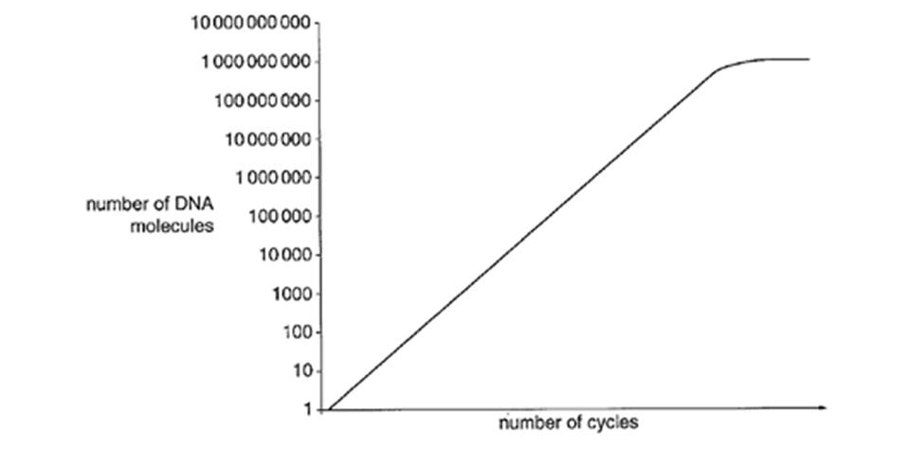  Fig. 2.2  Suggest two reasons why the graph levels off.  - Taq polymerase gradually becomes denatured;  - there are no more primers or deoxytrinucleotides available;  Reject: reactants had run out | [2]

 | (c) | Fig. 2.3 shows the genetic screening results for CF in a family. The amplified DNA containing KM-19 was digested with restriction enzymes followed by gel electrophoresis and Southern blotting using the probe shown in Fig. 2.1.  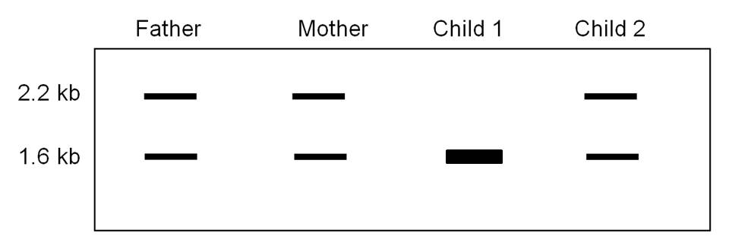  Fig. 2.3
 | (i) | Based on Fig 2.1 and the results shown in Fig. 2.3, explain if Child 1 is likely to get cystic fibrosis.  - Yes: presence of only 1.6kb fragments implies that the child has 2 mutant CFTR alleles; | [1]
 | (ii) | If Child 2 shows symptoms of CF, suggest a reason based on inheritance for the banding pattern obtained in Child 2.  - Banding pattern of 2.2kb and 1.6 kb implies child 2 is a carrier / only has 1 mutant CFTR allele;  If child 2 actually has CF, this means  - Crossing over occurred between KM-19 and CFTR loci during gamete formation in one of the parent;  - Allele 2 becomes linked to normal CFTR allele/ allele 1 becomes linked to mutant CFTR allele; | [3]
 | (d) | Recently, scientists discovered the presence of a population of bone-marrow derived stem cells that are distinct from hematopoietic stem cells. These multipotent stem cells have the ability to differentiate into lung epithelial cells and could possibly be used to replace the current methods of gene therapy for treatment of CF.  An experiment was carried out to compare the effects of 3 different treatments for CF.  CFTR-Knock Out (CFTR-KO) mice which did not express the CFTR gene were divided into 3 groups and given three different treatments.  - Treatment A: CFTR-KO mice were given a liposome-encapsulated DNA containing normal allele of CFTR by nasal aerosol.  - Treatment B: Bone marrow stem cells were transplanted from healthy donor mice expressing CFTR gene into CFTR-KO mice. The CFTR-KO mice in this group had their immune system suppressed to prevent them from rejecting the donor bone marrow stem cells.  - Treatment C: Lung epithelial cells were isolated from CFTR-KO mice and genetically modified. Cells which successfully express normal CFTR were introduced back into CFTR-KO mice.  Table 2.4 shows the percentage of lung epithelial cells with normal CFTR expression counted on 3, 7 and 10 days after the treatments.  Percentage of lung epithelial cells with normal CFTR expression  - : less than 20% + : 20 %- 39% ++ : 40 % - 60% +++ : more than 60%  Table 2.4
  Treatment | Mice | Percentage of lung epithelial cells with normal CFTR expression
  Treatment | Mice | Day 3 | Day 7 | Day 10
  A | 1 | +++ | ++ | -
  A | 2 | +++ | + | -
  A | 3 | +++ | ++ | -
  B | 1 | +++ | +++ | ++
  B | 2 | +++ | +++ | +++
  B | 3 | ++ | ++ | ++
  C | 1 | + | - | -
  C | 2 | - | - | -
  C | 3 | - | - | -

 | (i) | With reference to Table 2.4, explain why Treatment B is more effective than Treatment A.  Quote values  - At Day 3, all mice in treatment A and B has more than 39% of lung epithelial cells with normal CFTR expression;  - However by Day 10 , all mice in treatment A showed a decrease in percentage of lung epithelial cells with normal CFTR expression to less than 20% while mice in treatment B showed a higher percentage ( at more than 39% of lung epithelial cells with normal CFTR expression );  Explain  - In treatment B, bone-marrow stem cells could undergo self-renewal via mitosis to produce more / ensure constant source of stem cells containing normal allele of CFTR;  Accept converse argument for treatment A | [3]
 | (ii) | From the experiment, discuss the implications of the following treatments for CF patients:
 |  | Treatment B.  - Less repeated treatment required; | [1]
 |  | Treatment C.  - Data: Not effective as only 1 mice had 20 – 39% of lung epithelial cells with CFTR expression, which decreased to less than 20% from Day 7 onwards / 2 mice had less than 20% of lung epithelial cells with expression from Day 3 onwards;  - Reason: as it could be difficult for modified lung epithelial cells to reconstitute/ reform the epithelial layer of the lungs; | [2]
 |  | [Total: 17]

3 |  | Tobacco (Nicotiana tabacum) plants can be genetically modified to express a gene coding for a viral coat protein (CP) from the tobacco mosaic virus (TMV). CP, which is found on the surface of the virus, turns on the plant immune system. The transgenic tobacco plants with this gene will become vaccinated and therefore be immune to TMV. This increases yield of tobacco plants.  Several types of plant tissue cultures can be used for insertion of foreign genes, such as protoplast culture, root culture and anther culture.
 | (a) | Explain why protoplast cells are ideal transformation targets.  - No plant cell wall;  - Increased efficiency of uptake of foreign DNA; | [2]
 | (b) | The CP gene sequence is isolated from TMV and inserted into a Ti plasmid that also contains an antibiotic gene for selection in plant cells. The Ti plasmid is then inserted into a soil bacterium called Agrobacterium tumefaciens (Agrobacter) and subsequently used to infect tobacco protoplast cells. The transformed plant cells are grown in culture to regenerate tobacco plants.  Equal numbers of transgenic and normal tobacco plants (control) are inoculated with both TMV and tomato mosaic virus (ToMV) and left for five days.  The mean percentage of surviving leaves was calculated in each type of tobacco plants and the results are shown in Fig. 3.1  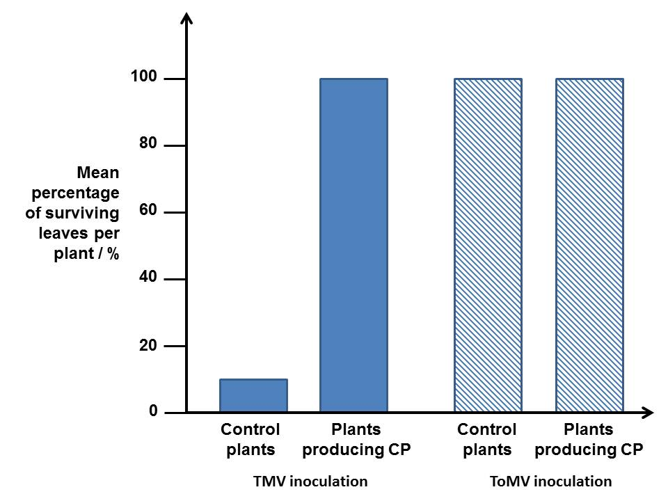  Fig. 3.1  With reference to Fig. 3.1,
 | (i) | explain the effect of CP on the yield of tobacco plants inoculated with TMV.  - CP increases the yield of tobacco leaves as control plants have 10% of surviving leaves which is lower than the 100% of surviving leaves in plants producing CP;  - Virus unable to replicate in tobacco plant cells producing CP as the plants are immune; | [2]
 | (ii) | explain if CP vaccinates tobacco plants against ToMV.  - Control plants and plants producing CP both have 100% of surviving leaves;  - Tobacco plants may already have immunity against ToMV;  - ToMV unable to infect the tobacco plants as it is unable to bind to plant cell membrane / wall surface receptor molecules;  [max 2m] | [2]
 | (c) | An alternative method of vaccinating tobacco plants against TMV is to transform tobacco plant cells with a gene coding for RNA (siRNA) which has complementary sequence to the viral mRNA of a TMV protein critical for viral replication. The translation of viral mRNA into viral proteins is reduced.  Explain how expression of siRNA can lead to the reduction of viral mRNA translation.  - siRNA binds viral mRNA to form double stranded RNA via complementary base pairing;  - prevents the tRNA anticodon from binding to viral mRNA codon / prevent ribosome and translation factors from binding to viral mRNA to form translation initiation complex; | [2]
 | (d) | Genetic engineering which involves introducing genes from other species into crop plants has also led to production of crops such as Bt corn and golden rice.  Between the years 1900 and 2000, crop yields across the world increased by almost 300%.  Discuss why such genetic engineering has contributed little to this rise in yield and explain your answer.  - GM food has only recently been developed / approved for human consumption;  - Bt corn reduces insecticide use, rather than being designed to increase yield;  - Golden rice only improves quality, not yield;  - Yield is unlikely to be under the control of a single gene, genetic engineering in a single organism involving multiple genes has not been successful;  [max 3m]  Reject: any ethical arguments or cost implications of seed patents | [3]
 |  | [Total: 11]

4 |  | Planning question
P1 is a temperate phage that infects Escherichia coli. It is an unusual phage in that during the lysogenic stage, it’s DNA remain transcriptional silent and exists as an independent circular DNA plasmid-like element rather than integrates into the host genome like other temperate bacteria phage. In its lytic phase, P1 can produce transducing phages which carry part of the bacterial genome. Induction of P1 from the lysogenic cycle to the lytic cycle is known to occur over a temperature range of 32ºC to 52ºC.

You are required to plan, but not carry out, an investigation to determine the optimum temperature at which induction of P1 phage from the lysogenic cycle into the lytic cycle occurs.

Induction from the lysogenic to lytic cycle can be determined by observing the gene expression of β-galactosidase. β-galactosidase is an enzyme made up of two peptides, lac Z-α and lac Z-Ω, neither of which is active by itself but when both are present together, they spontaneously reassemble into a functional enzyme.

In mutant E.coli with a deletion in the lac operon, β-galactosidase lacking the lac Z-α is produced. The mutation can be repaired by transduction with P1 transducing phages which have been previously been reproduced in E.coli that do not contain the deletion in lac operon. These transducing phages contain DNA encoding lac Z-α.

Upon transduction of the mutant, lac operon deficient E.coli with transducing phages containing DNA encoding lac Z-α, the amount of β -galactosidase produced in the bacterial cell can be measured using a colorless chemical known as X-gal. Hydrolysis of X-gal by β -galactosidase will result in the formation of a blue product. The color intensity of the product can then be assayed using a colorimeter which measures the absorbance of different wavelengths of light in a solution in absorbance units (A.U). A solution of higher color intensity will absorb more light energy at a specific wavelength.

Your plan should:

- have an explanation of theory to support your practical procedure
- have a clear and helpful structure such that the method you use is able to be repeated by anyone reading it
- include layout of results tables and graphs with clear headings and labels
- include full details and explanations of the procedures that you would adopt to ensure that the results obtained were as quantitative, precise and reliable as possible
- include relevant risks and precautions taken.
[Total: 12]

Your planning must be based on the assumption that you have been provided with the following equipment and materials, which you must use:

- a glucose-deficient liquid culture of mutant E.coli previously infected with P1 transducing phages carrying DNA encoding for lac Z-α. The transduced mutant E.coli culture is kept at 30ºC. P1 phages are known to exist as lysogens in mutant E.coli cells at 30ºC.
- lactose solution
- thermostatically regulated waterbath
- colorimeter with accompanying cuvettes
- liquid X-gal
- stopwatch
- sterile test tubes
- a variety of syringes for measuring volumes
Theory and Hypothesis (2m)

T1 During lysogenic cycle, presennce of repressor protein prevents expression of genes / transcription of phage genes
T2 transcription/ expression of lac-α (on phage DNA) occurs only during the lytic cycle;
T3 At the optimum induction temperature, there are most number of phages which undergoes lytic cycle;
T4 Highest amount of lac-α produced which assembles with lac-Ω to form most number highest amount of β-galactosidas
T5 highest amount of X-gal hydrolysed (to produce more blue compound)
T6 Bacterial culture has the highest color intensity → highest absorbance;

Method (6 m)

- Production of lac-Ω by bacteria cells during the lysogenic cycle
M1 Add in a fixed/ numerical volume of lactose to a fixed /numerical volume of transduced mutant E.coli culture in a test tube using syringes;
M2 Incubate at 30ºC in a thermostatically regulated waterbath;
M3 for a fixed period of time (20mins – 1 hour) time with a stopwatch;

Purpose:
M4 alloactose will bind to lac repressor, causing the lac repressor to no longer bind operator;
M5 RNA polymerase can bind to unblocked promoter → to allow the lac operon to transcribe and translate lac-Ω (which is required to assemble with lac-α to form functional β-galactosidase during the lytic cycle);

- Induction
M6 Add in stated volume of X-gal to test tube containing lactose, transduced mutant E.coli culture
M7 Incubate at stated temperature ( 32⁰C) in thermostatically regulated waterbath;
M8 Incubate for a fixed period of time (accept 10 mins - 1hour) time using a stopwatch;

√ Measuring amount of β-galactosidase produced
M9 remove a small volume of mixture and place into a cuvette using syringe;
M10 measure absorbance using colorimeter;
M11 Perform 2 more replicates at each temperature to obtain average absorbance;
M12 Repeat experiment at least 4 more temperatures (temperature range from 32ºC to 52ºC, even intervals);
M13 Repeat entire experiment twice to ensure reproducibility;

- Use of apparatus and techniques
M14 Mention use of thermostatically waterbath in M2 and M6;
M15 Mention use of stopwatch in M3 and M7
M16 Mention use of syringes and test tubes to measure -transfer volumes of liquid and hold liquid culture respectively in M1 and M8
M17 Mention aseptic techniques to prevent contamination

Accept e.c.f for steps not mentioned in procedure

Award max of 4m only if leave out the procedure for production of lac-Ω by bacteria cells during the lysogenic cycle

Control (1m)

C1 Control: transduced mutant E.coli culture + lactose incubated at 30ºC subjected to the same experimental conditions;
C2 Purpose: To show that transduced mutant E.coli produce functional β-galactosidase only upon induction of P1 phage into the lytic cycle;

Results (2m)

- Table
R1 correct headings with appropriate units;
R2 Replicate and average included;

Temperature/ ºC | Absorbance / A.U
Temperature/ ºC | Replicate 1 | Replicate 2 | Replicate 3 | Average
32
36
40
44
48
52

- Graph
R3 x-axis: temperature / ºC, y-axis: average absorbance / A.U
allow ecf from R1 and R2;
R4 Graph drawn with a peak at optimum temperature;

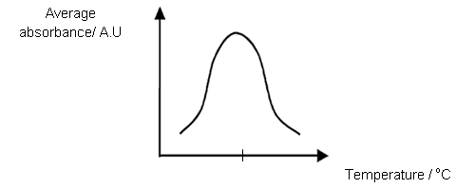

Safety (1m)

S1 Risk: Exposure/ contact with bacteria or bacteriophage may result in bacterial or viral infection
S2 Precaution: any 1
  - Before starting work, cover all cut or broken skin with a waterproof dressing;
  - Wear gloves;
  - Before and after each working session clean the bench surface with 70% ethanol / swab any spillages with bactericidal disinfectant;
  - All solutions and apparatue that have come into contact with bacteria and bacteriophage should be placed in fresh 10% bleach solution for sterilization before disposing them;

Free-response question

Write your answers to this question on the separate answer paper provided.

Your answer:

- should be illustrated by large, clearly labelled diagrams, where appropriate;
- must be in continuous prose, where appropriate;
- must be set out in sections (a), (b) etc., as indicated in the question.

5 | (a) | Outline Nucleic Acid Hybridisation and explain how it can be used in the detection of DNA sequences.  - The formation of a double-stranded nucleic acid molecule by binding of one single stranded nucleic acid to another;  - Via complementary base-pairing / formation of hydrogen bonds between complementary bases;  - Possible hybrid nucleic acid molecules, two strands of DNA, two strands of RNA or DNA-RNA hybrid molecules;  [max 2m]  - Southern blotting is a method that uses nucleic acid hybridisation to detect specific DNA sequences;  - DNA fragments of different sizes separated by gel electrophoresis  - Double-stranded DNA are denatured into single strands by adding alkali to the gel;  - The denatured DNA is transferred to a piece of nitrocellulose membrane by capillary action;  [max 2m]  - Colony hybridisation is a method that uses nucleic acid hybridisation to identify which bacteria colonies on an agar plant contains a specific DNA sequence of interest / target DNA sequence;  - Colonies on an agar plate is pressed against a nitrocellulose membrane  - Treated with alkali to lyse cells and denature DNA;  [max 2m]  - membrane then incubated with a labeled single-stranded DNA or RNA probe;  - Probe has complementary sequence to the target DNA sequence / sequence of interest;  - If target DNA sequence is present, probe will hybridise with the target DNA and indicate its presence;  - Hybridised probe is detected via autoradiography, color development or development of fluorescence on membrane;  - Nitrocellulose membrane will show a visual band where the probe hybridized with the complementary target DNA;  [max 4m] | [10]
 | (b) | Discuss the ethical implications of genetically modifying plants.  - GM plants grown as crops may lead to consumers having allergies as foreign proteins are produced in the plants, companies need to label their GM crops for consumers to make informed choices;  - Animal genes may be introduced to plant genomes, leading to concern of vegetarians and some religious groups which followers are not allowed to consume certain animals;  - Genetic modifications of certain plants may affect food chains / certain animals that feed on the plants.  - E.g. of genetic modifications of plant which affect food chain: Bt corn plant pollen blown onto milkweed plants can be ingested by the Monarch Butterfly;  - Cross-pollination of GM plants with other non-crop plants lead to transfer of genes, affecting ecological balance;  - E.g of transfer of genes to non-crop plants leading to ecological balance disrupted: Bt gene transferred to non-crop plants leading to these plants producing toxin killing desirable insects such as Monarch butterfly;  - GM crops lead to benefits that rich countries can enjoy due to more financial resources at the expense of poorer countries;  - GM crops can produce higher quality food to allow large companies that develop the technology to out-compete small scale farmers;  - Example: Golden rice, Bt corn;  - Tampering with nature, where the mixing of genes among species may be seen as violation of organisms natural intrinsic values, crossing species boundaries;  - AVP;  [max 5m] | [5]
 | (c) | Discuss the goals of the human genome project.  - To determine the sequence of the coded information contained in the DNA of the various genomes studied and from this to identify all of the estimated 30,000 human genes;  - Constructing a detailed physical map of the entire human genome;  - Functional genomics: studying genes’ normal functions, the extent to which they vary from person to person and the role of this variation in causing or contributing to developmental, growth and health problems;  - Storing all sequence information in databases that are accessible by all;  - Studying and addressing the ethical, legal and social implications (ELSI) of genome research;  - Improving tools for analysis such as sequencing technology development, developing technology for functional genomics, developing technology in bioinformatics;  - Completing the sequences of several other organisms such as bacteria, yeast, Drosophila melanogaster and the mouse, to be used as models for research. Knowledge gained by the study of genomes of other organisms would assist in the analysis of the human genome;  [max 5m] | [5]
 |  | [Total: 20]

